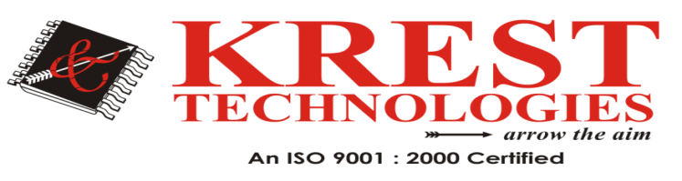

M.Tech CSE Major Projects List (2020-2021)

 | Artificial Intelligence
1 | An Interactive Perception Method for Warehouse Automation in Smart Cities | 2021
2 | Attention Consistent Network for Remote Sensing Scene Classification | 2021
3 | A Realistic Image Generation of Face From Text Description Using the Fully Trained Generative Adversarial Networks | 2021
4 | Person Re-Identification With Reinforced Attribute Attention Selection | 2021
5 | Integrating Stacked Sparse Auto-Encoder Into Matrix Factorization for Rating Prediction | 2021
6 | An Unsupervised Ensemble Clustering Approach for the Analysis of Student Behavioral Patterns | 2021
7 | Trustworthiness in Industrial IoT Systems Based on Artificial Intelligence | 2020
8 | Explaining Deep Learning-Based Traffic Classification Using a Genetic Algorithm | 2020
9 | Progressive Learning for Person Re-Identification with One Example | 2019
10 | Fine-Grained Image Classification Using Modified DCNNs Trained by Cascaded Softmax and Generalized Large-Margin Losses | 2019
11 | A Cross-Domain Recommender System With Kernel-Induced Knowledge Transfer for Overlapping Entities | 2019
12 | A Deep Neural Framework for Continuous Sign Language Recognition by Iterative Training | 2019
13 | Deep Additive Least Squares Support Vector Machines for Classification With Model Transfer | 2019
14 | PCCA: Position Confidentiality Conserving Algorithm for Content-Protection in e-Governance Services and Applications | 2018
15 | DeepClue: Visual Interpretation of Text-based Deep Stock Prediction | 2018
16 | Improving Deep Learning Performance Using Random Forest HTM Cortical Learning Algorithm | 2018

HeadOffice: #202 2nd Floor, Pancom Business Center Opp, Chennai Shopping Mall, Ameerpet, Hyderabad 040-44433434 Mail-id: ramu.krest@gmail.com,www.kresttechnology.com

